**GUIDELINES FOR ONLINE COUNSELING**

**Process Flow**

OPEN THE WEBSITE  [WWW.WBSCVT.NE](http://www.wbscvt.net/)T

* **CLICK ON “Candidate Login”**

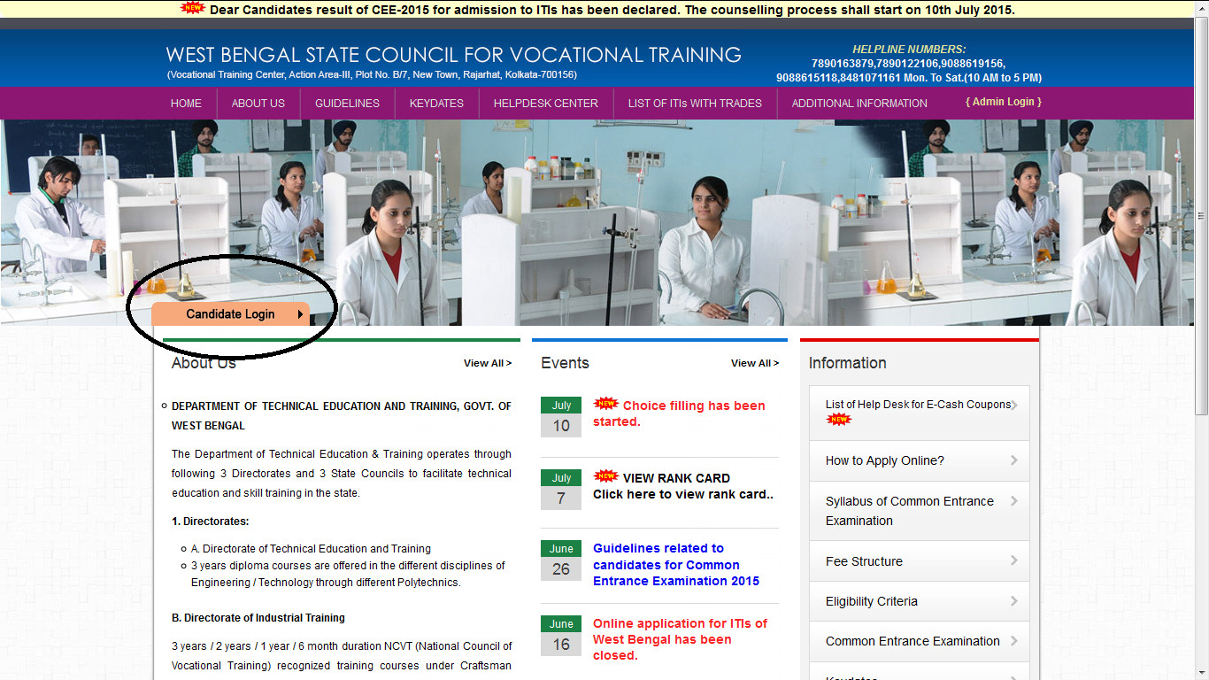

* FILL YOUR **APPLICATION / OMR NO, DATE OF BIRTH AND CLICK ON LOGIN**

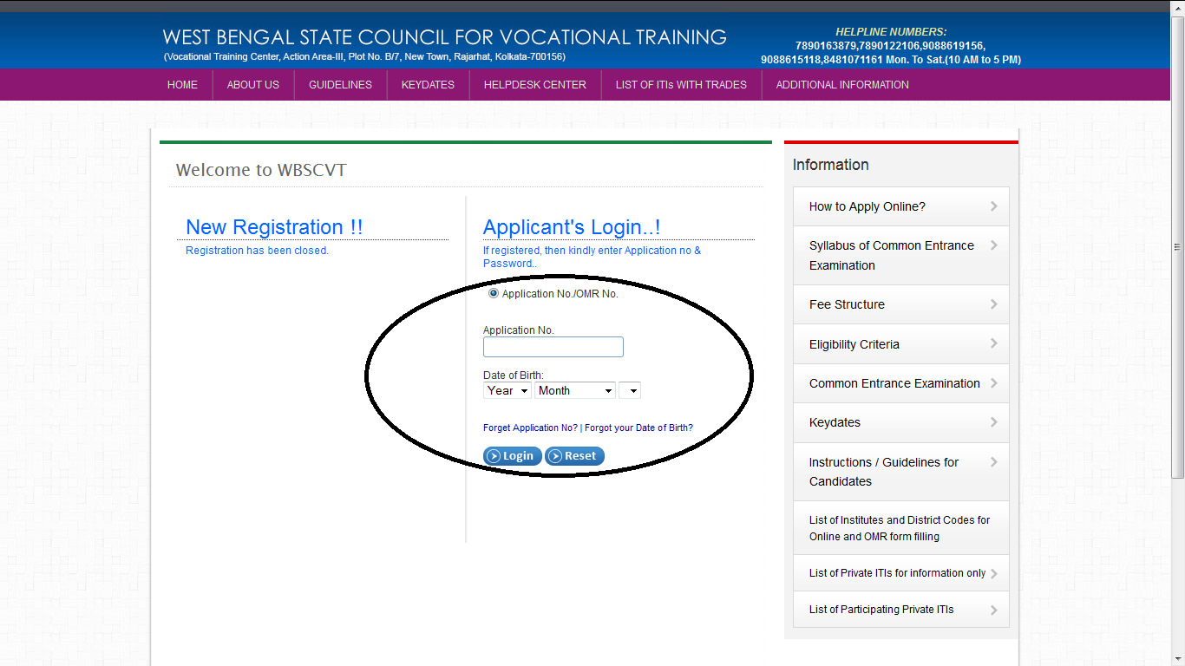

* **AFTER LOGIN A PAGE WILL APPEAR, KINDLY CHECK ALL YOUR DETAILS AND EDIT (IF REQUIRED).**

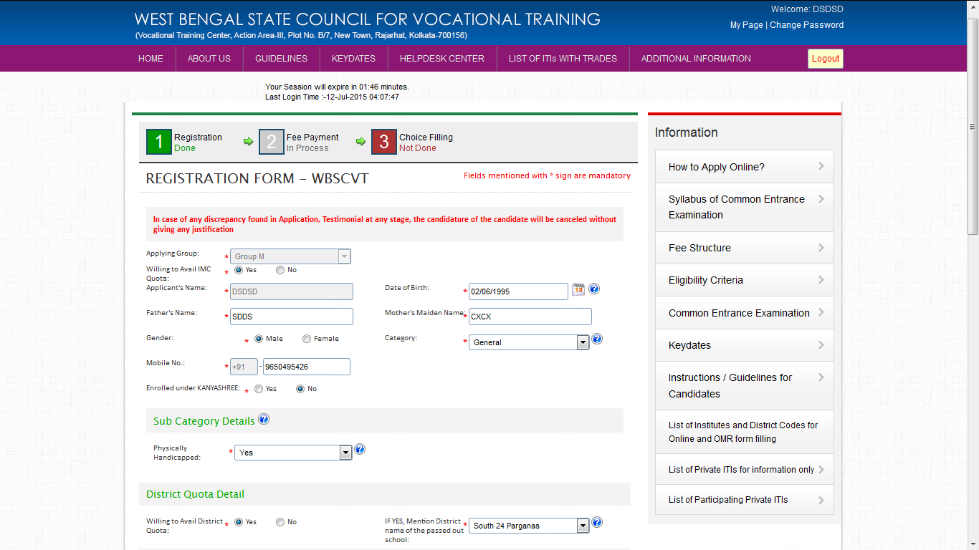

* **MY PAGE WILL APPEAR ON SCREEN**

**CLICK ON COUNSELING STATUS “ PAY COUNSELING FEE”**

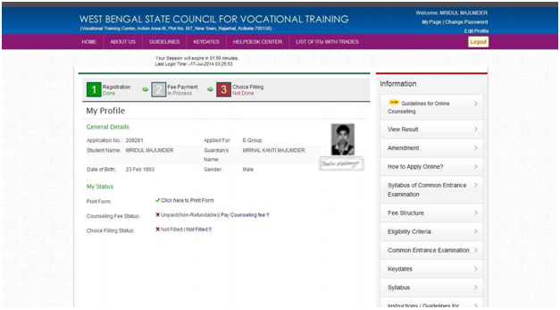

* **THEN CLICK ON “e-Cash Coupon Receipt as your payment option**

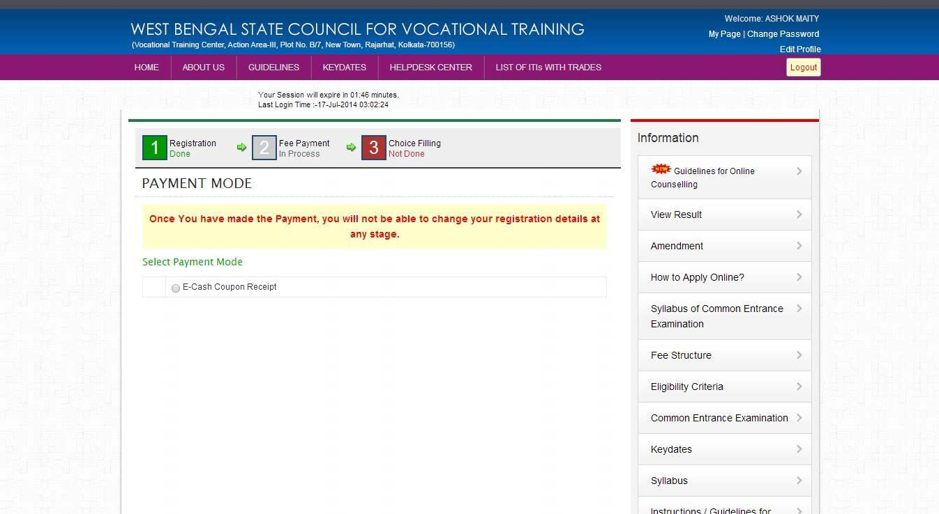

* **READ CAREFULLY THE INSTRUCTIONS TO FILL E-CASH COUPON PAYMENT DETAILS AND CLICK**

**ON “PROCEED”**

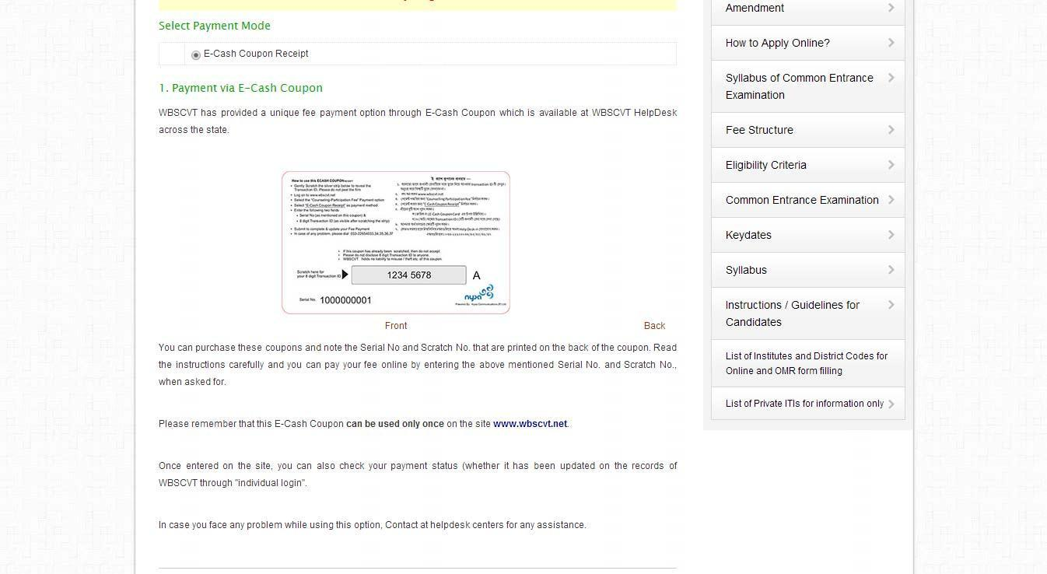

* **Enter Serial No. and Transaction ID AVAILABLE ON THE BACK SIDE OF E-CASH COUPON.**

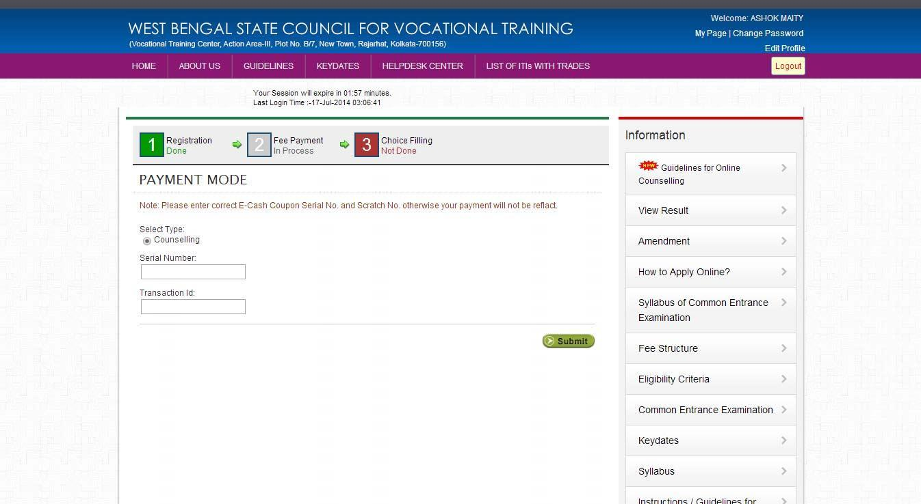

* **AFTER FEE PAYMENT CLICK ON “ CLICK HERE TO FILL CHOICES”. OTP popup will display enter OTP sent to your registered mobile no. After successful verification of OTP you can see the choice filling page, there is option to filter Govt./Raymond Inst./Private Institutes.**

                              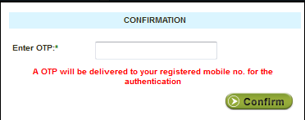

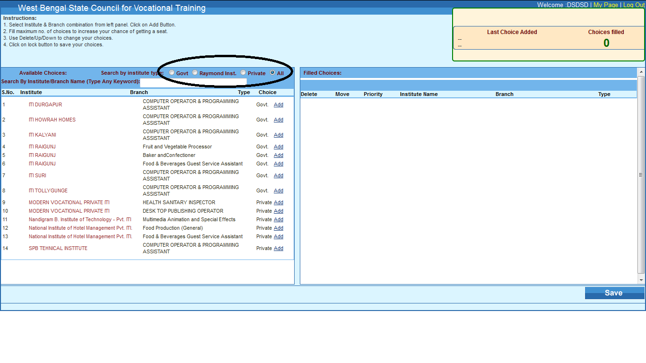

* **ON LEFT SIDE ALL CHOICES WILL APPEAR YOU JUST CLICK ON “ADD”.**
* **YOU CAN ADD YOUR CHOICES AS PER YOUR PRIORITY, YOU CAN ALSO EDIT , DELETE YOUR CHOICES.**
* **AFTER COMPLETE THE CHOICES CLICK ON “SAVE”.**

**CRITERIA FOR CHOICE FILLING**

1.Candidate applied for “M” group of trade can only be allowed to provide choice for “M” group of trades available in different Govt./Private ITIs only. List attached with this document.

2.Candidate applied for “E” group of trade can only be allowed to provide choice for “E” group of trades available in different Govt. /Private ITIs only.

3.Candidates not having Mathematics & Science will not be allowed to provide choice for any engineering trade in “M” group.

4. “Candidates previously admitted in any trade (of any Group) of a Govt. ITI/ITC/JP (irrespective of completed the course or discharged from the course) shall not be eligible for admission in that particular ITI/ITC/JP for consecutive three years from his pass out year. A trainee appeared/Passed out/ discharged from any Govt. ITI/ITC/JP shall not be eligible for admission in any other Govt. ITI/ITC/JP for the session starting from the next academic year.